**PROJECT REPORT**

**BUSINESS INTELLIGENCE AND DATA VISUALIZATION**

**INDIAN PREMIER LEAGUE**

**MADE BY:-RISHABH SAINI (18CSU172)**

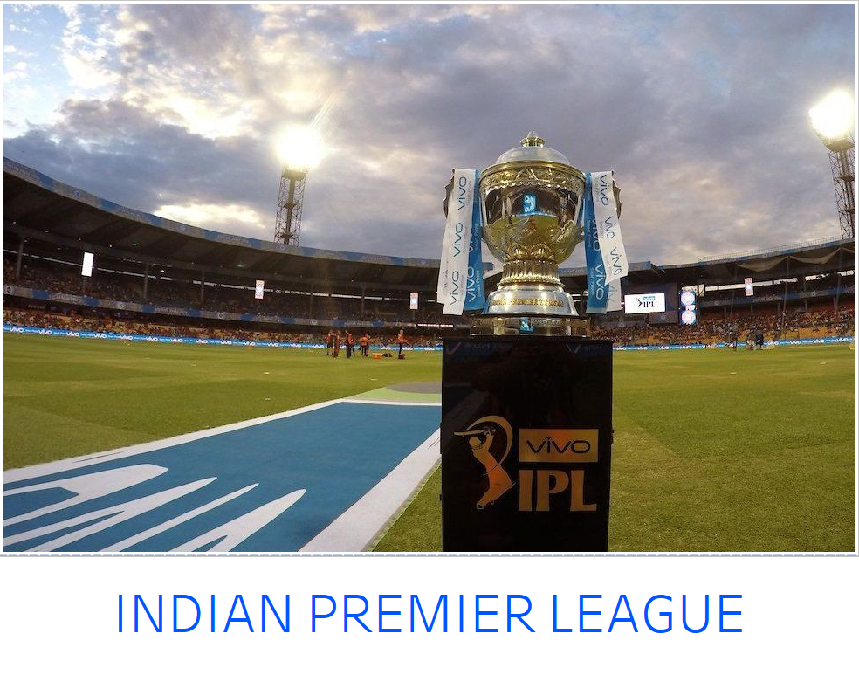

**VISUALIZATION ANALYSIS**

**MAP:**

A **map** is a symbolic representation of selected characteristics of a place. **Map** present information about the world in a simple, visual way.

In this map is showing the geographic location of the ipl matches that being played in all the countries and their places.

From this we conclude that the matches were being played in the countries like UAE and South Africa

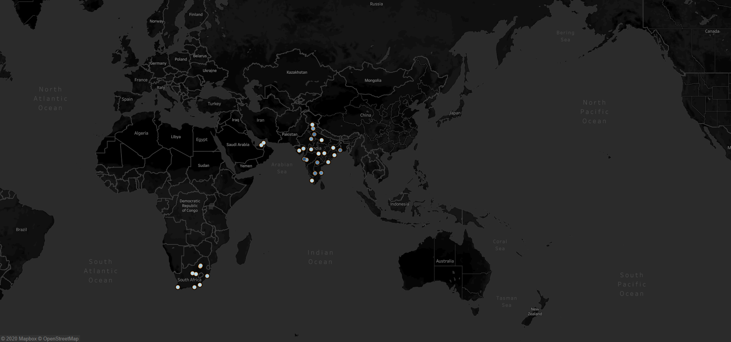

**Lollipop Chart:**

The **lollipop chart** is a composite **chart** with bars and circles. It is a variant of the bar **chart** with a circle at the end, to highlight the data value.

This shows the no. of matches played at each stadium.There are various

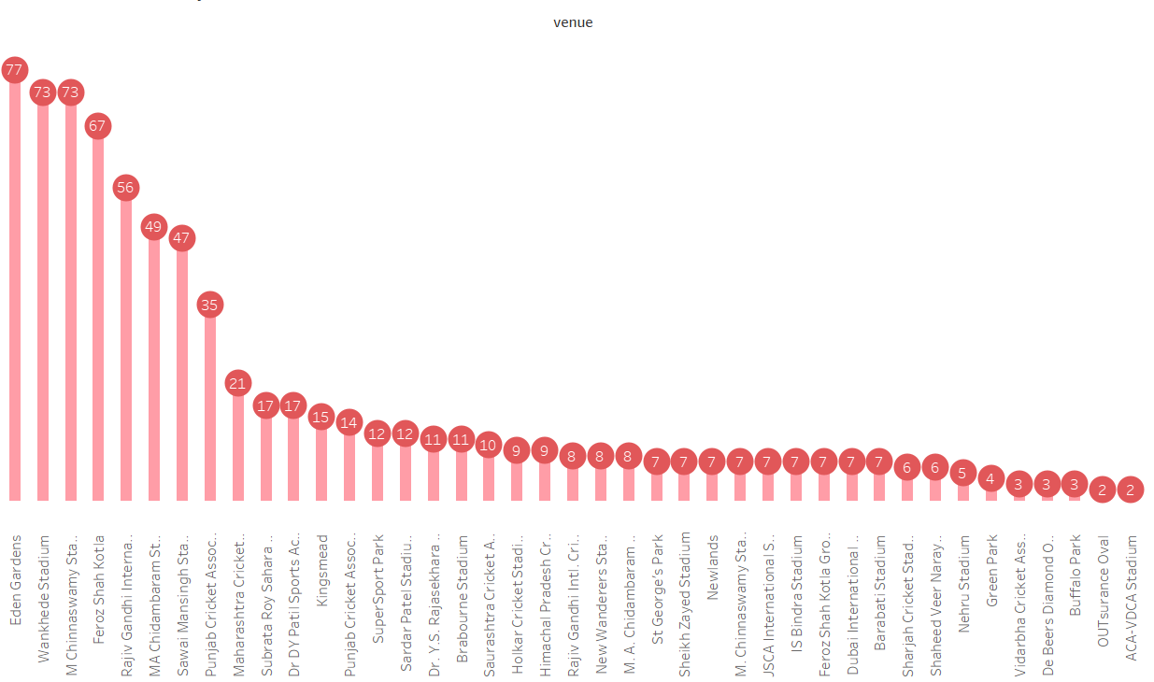no. of stadiums where stadiums like Eden garden, Wankhede, M Chinnaswamy, Feroz Shah Kotla,etc Stadiums have most no. of matches than the it is of the fact such stadiums are the home ground of the team

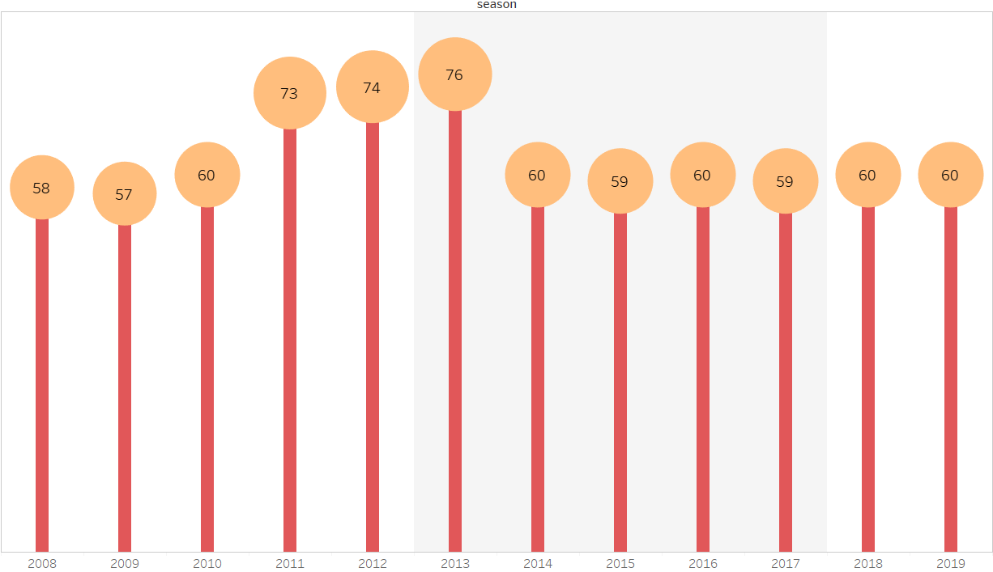This lollipop chart shows the no. of matches played in each season. Here we can see in the like 2011, 2012, 2013 have more than other because in that season their were 10 teams rather than 8.

**Bubble Chart:**

**Bubble charts** display data as a cluster of circles. Each of the values in the dimension field represents a circle whereas the values of measure represent the size of those circles.

This Bubble chart shows top toss winning team.

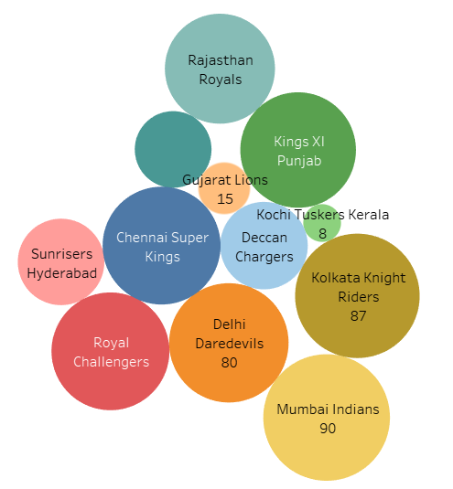

**Rounded Bar Graph:**

**Rounded bar Graph** are a highly versatile way to visually communicate data complex data easy to understand at a glance.

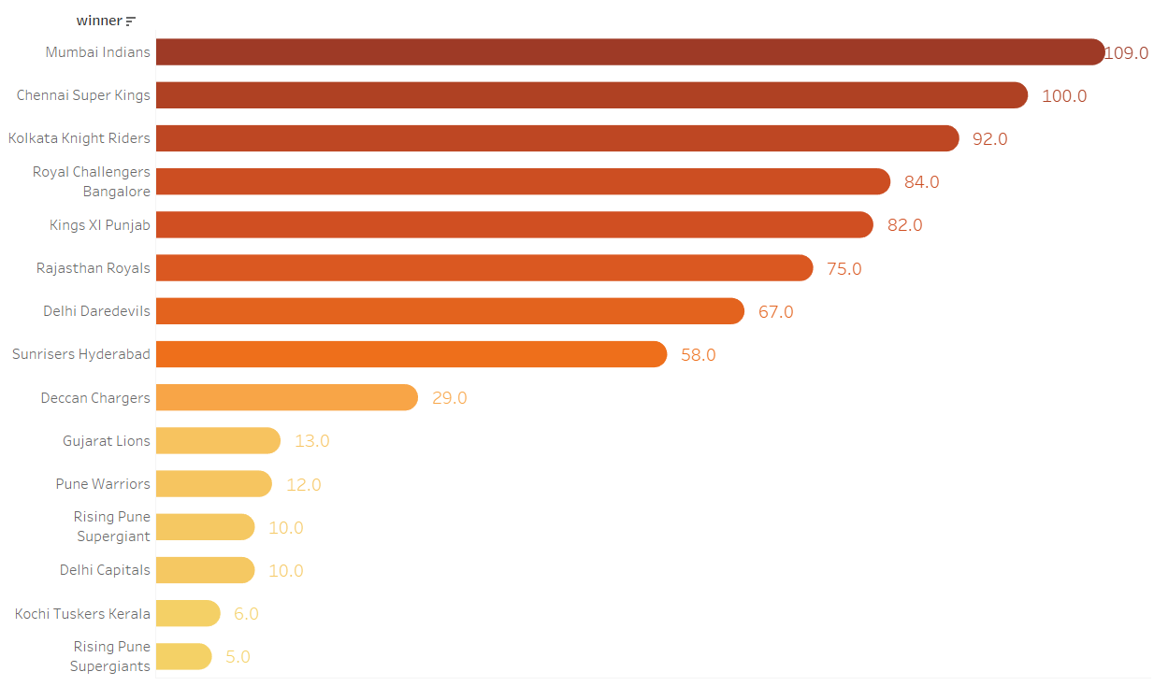The graph represent the statistics of the no of matches won by each ipl team. The Mumbai Indians have won most no of matches and so because they are leading title winner of this tournament by grabing it four times and after Chennai Super Kings have second best record which also the top class team of the tournament.

**Bar Graph:**

A **bar graph** is a chart that uses bars to show comparisons between categories of data. The bars can be either horizontal or vertical. Bar graphs with vertical bars are sometimes called vertical bar graphs. A bar graph will have two axes. One axis will describe the types of categories being compared, and the other will have numerical values that represent the values of the data.

This is specially designed graph used with filters which helps to describe leading run scorer of each team from each season. From this we can analyse the performance of batsman and can also find top performer of the season .

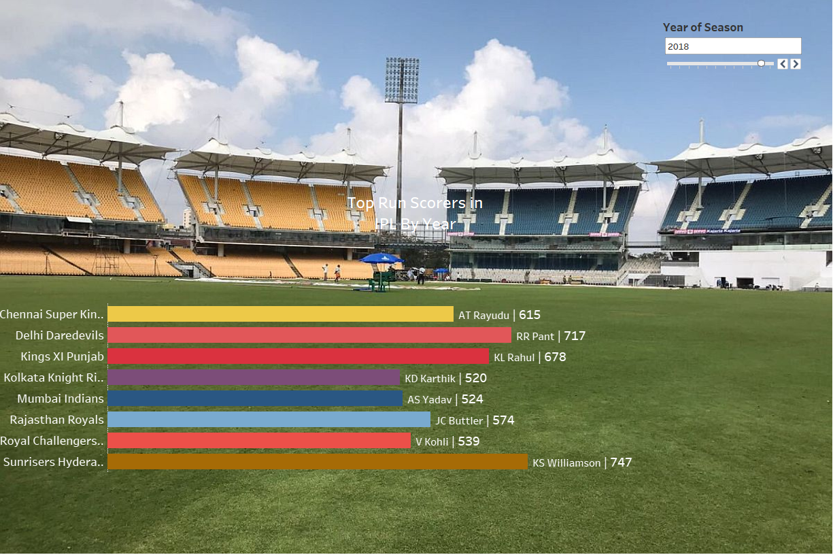

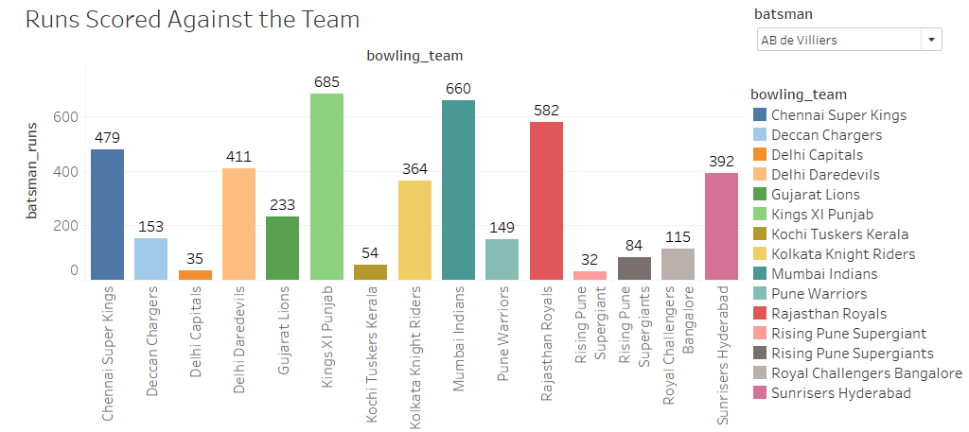This graph desribe the statistics of batsmans where the help of filter we can analyse performance of each player against each team.

**Pie Chart:**

A pie chart is a type of graph in which a circle is divided into sectors that each represents a proportion of the whole. Pie charts are a useful way to organize data in order to see the size of components relative to the whole, and are particularly good at showing percentage or proportional data.

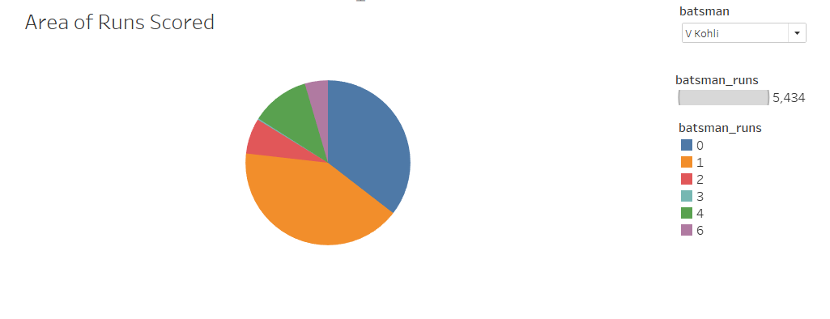This Pie Chart describe the area of runs scored by each batsmen.

**Bump Chart:**

A **Bump Chart** is used to compare two dimensions against each other using one of the Measure value. They are very useful for exploring the changes in Rank of a value over a time dimension or place dimension or some other dimension relevant to the analysis.

This is a specially Designed Bump Chart where it describes the free floatation of strike rate of top 8 batsmen of all season.

This help us to understand rate at which a player is its ining in each year.

The other important thing in this is that I have taken an average constant line of 130.77 strike rate .So it helpful in indicating their string power.

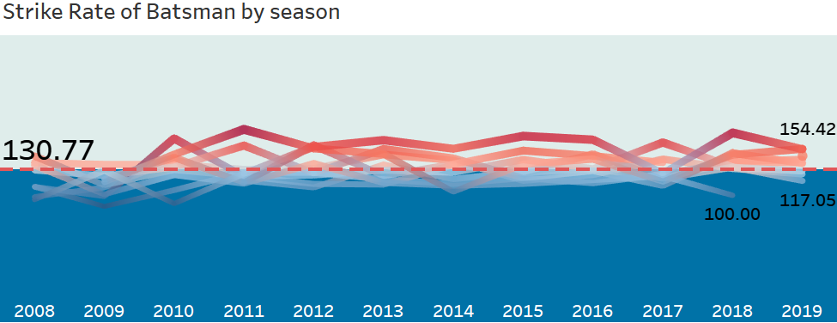

**Combination Chart:**

The combination chart is a visualization that combines the features of the bar chart and the line chart. The combination chart displays the data using a number of bars and/or lines, each of which represent a particular category.

A combination of bars and lines in the same visualization can be useful when comparing values in different categories, since the combination gives a clear view of which category is higher or lower.

Here I have describe the performance of wining team by comparing their performance on batting bowling first.

From this we can conclude that wining team has better performance while bowling first. This is because team which bowls first have to bat at second ining. While this increase the chance of dew factor and more dew can help the batsmen in scoring the run easy because the bowl is wet and team can easily chase the target.

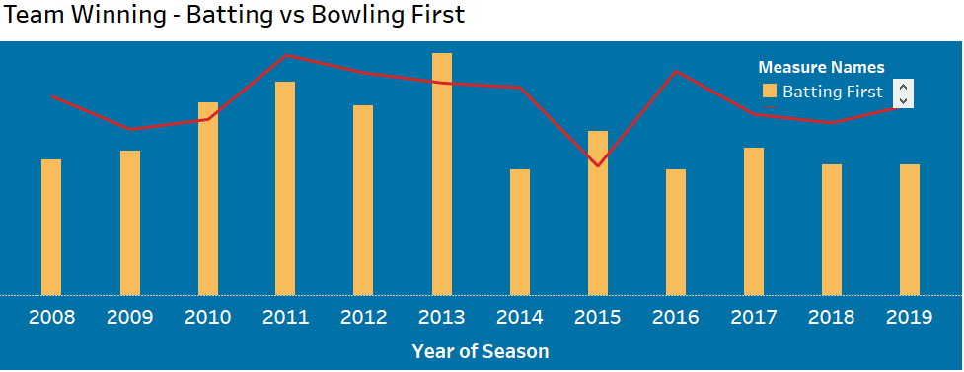

**Area Chart:**

An **area chart** or **area graph** displays graphically quantitative data. It **is** based on the line are. The area between axis and line are commonly emphasized with colors, textures and hatchings. Commonly one compares two or more quantities with an **area chart**.

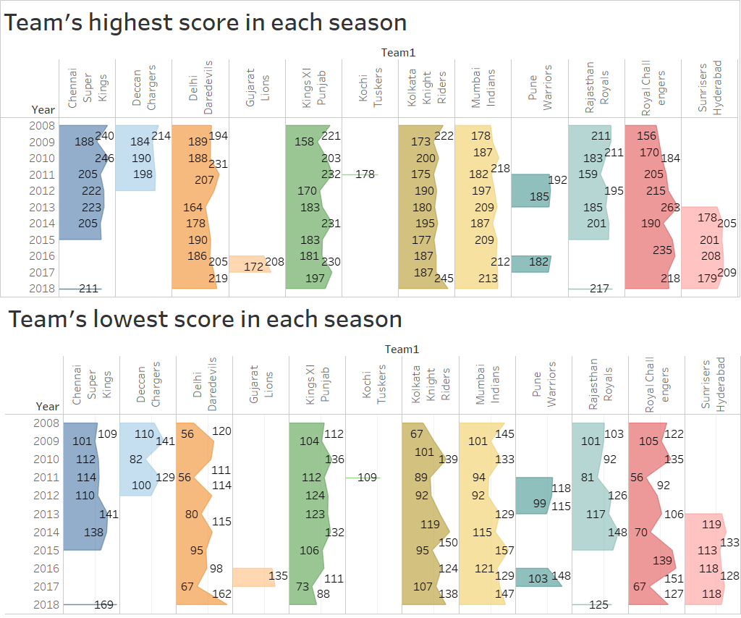

**Butterfly Chart:**

A **Butterfly Chart** (also called Tornado Chart) is a type of bar chart where two sets of data series are displayed side by side. It gives a quick glance of the difference between two groups with same parameters.

The main use of the butterfly chart is comparison of two data sets sharing the same parameters.

This butterfly chart shows average runs scored in each city where left side shows team 1 which is the home team and right side shows team 2 which is the visiting team. In this we can see that averge of team 1 is higher than team 2 . This is so because team 1 is playing in their home ground where they know the pitch very well and have more experience.

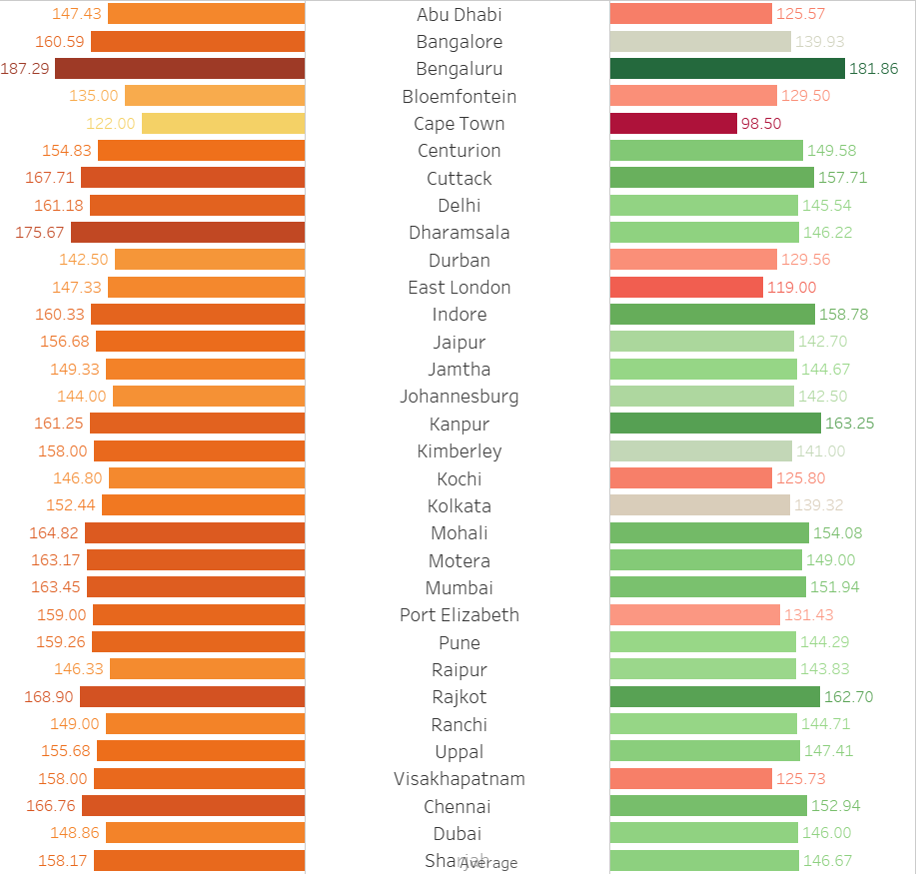

**Donut Chart:**

It is similar to **pie chart** which divides the a circle in different sectors based on the value of their proportions. But, the difference between **Pie** and **Donut chart** is that in a **donut chart** there can be more than one data series added as rings to the chart.

The chart shows the average score of the team.

This helps us in visualizing the average score of each team where we can se team like Mumbai Indians, Chennai Super Kings, RCB have good average score the reason for these is that the stadium in which these teams played are suitable for batting team because of flat surface and another reason is that they have good quality and power hitting batsmen.

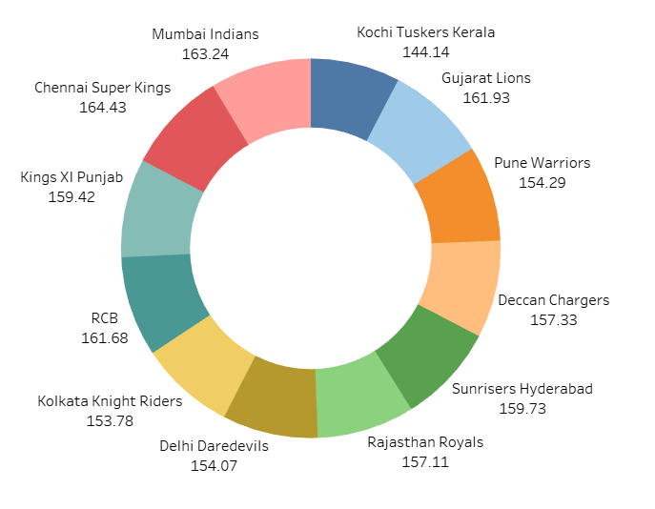

**Line Chart:**

**Line charts** connect individual data points in a view. They provide a simple way to visualize a sequence of values and are useful when you want to see trends over time, or to forecast future values.

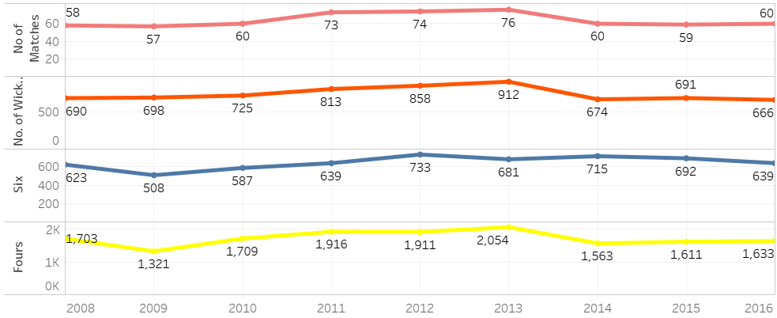This line chart shows the stats of fours, sixes, no. of wickets and no. of matches with trends from each year.

**Pareto Chart:**

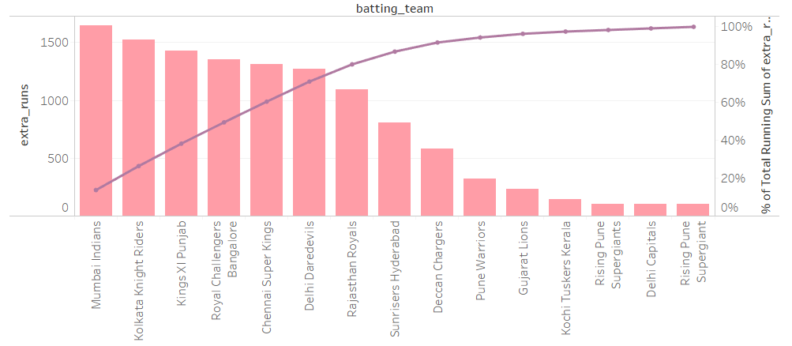A **Pareto chart** is a type of chart that contains both bars and a line graph, where individual values are represented in descending order by bars, and the cumulative total is represented by the line. Pareto chart for extra runs with teams. This shows exta runs given by the teams. It follows 80-20 principal.

**Heat Map:**

A heat map is a two-dimensional representation of data in which values are represented by colors. A simple heat map provides an immediate visual summary of information. More elaborate heat maps allow the viewer to understand complex data sets.

As the marks “**heat** up” due their higher values or density of records, a more intense color is displayed.

This heat map shows the average no. of total runs scored by batting team.

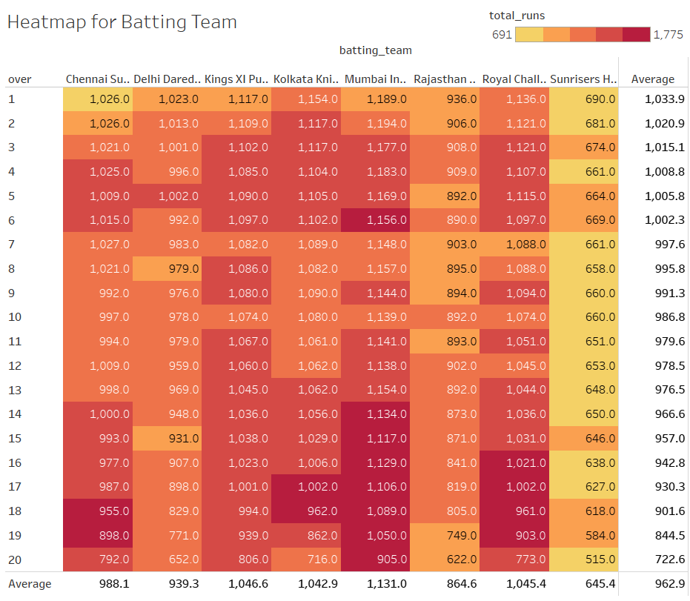

The both the heat map shows the density of runs scored and conceded by the respective team. Here we can conclude the that density are higher in 1-6 overs because of powerplay overs. In ipl matches there is powerplay of 1-6 overs where only two fielder can stand out side the 30 yard which only will stand in boundary line. Hence, which allows batsmen to freely scores the runs and from bowling side they have to make strategies to stop the flow of runs.

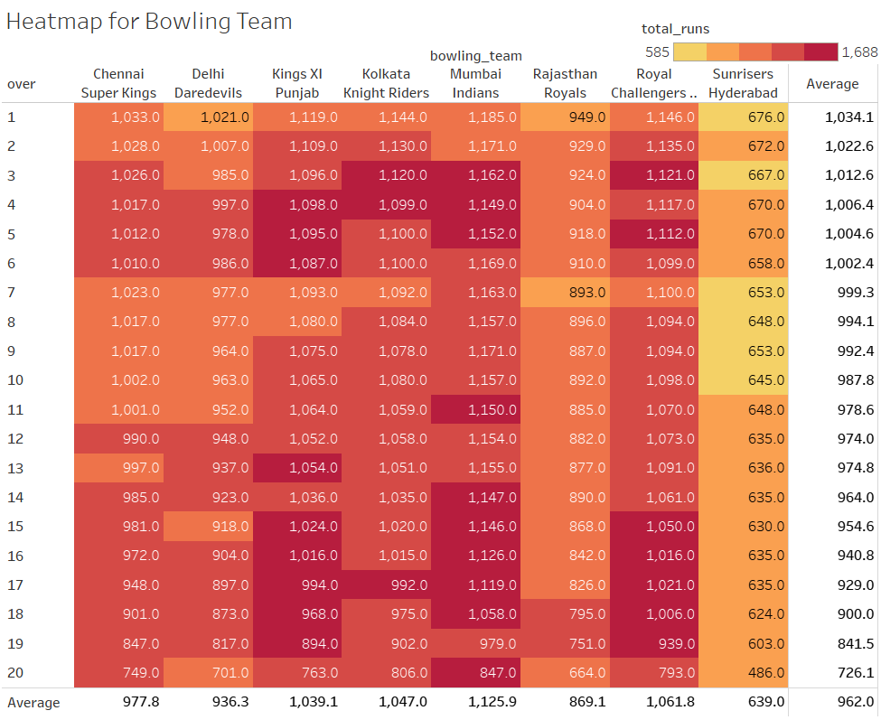 This heat map shows the average no. of total runs conceded by bowling team.

**A/B Testing:**

A/B testing is the process of comparing two variations of a page element, usually by testing data' response to variant A vs variant B, and concluding which of the two variants is more effective.

Here A/b testing is done to visualize The Home Team and The Visiting Team on the basis of toss decision which mean what the team decide to choose after winning the toss, bat or field.

In both the test we can see that the teams elect to field first rather than to bat. This means that teams like to chase the target instead of giving the target. Another reasons for this is that of dew factor.

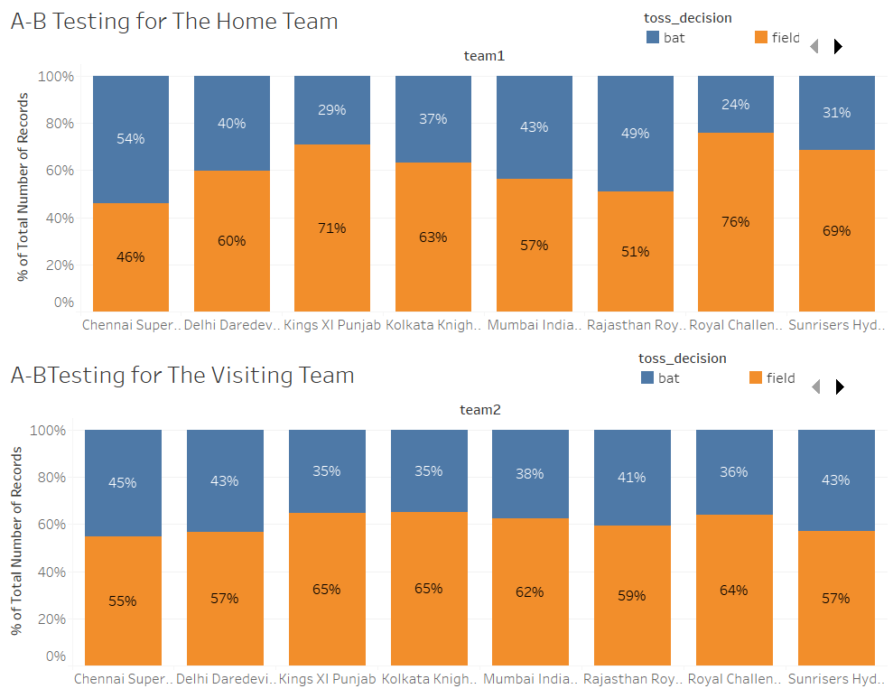

**Future Scope:**

IPL to me looks a very good option as far as providing the exposure to the young lot is concerned having played with the biggies of the games likes of Sachin, Kumble, Ponting etc. still hanging around with teams. As far as the skills is concerned, it does not dig deep into skill-testing especially for the batsmen, bowlers can still show their intelligence and skill by sticking to basics and containing the batter.

IPL is a place from where new talents are coming over time and there is no reason for not believing that today India in international match is strong Jst as it gets new young players over a time which helps a lot in making India a good team

This league also increases market and media publicity and allows investor and franchise to invest in such.

The data is also helpful during auction through which they can analyse the performance of player.

And coming to the future, it has great scope and potential and with BCCI taking care of it so well it does not seem the trophy is can lose any shine in near future.